PRESS RELEASE

**The Kulturstiftung Basel H. Geiger | KBH.G presents**

**ROOTS, One Hundred Years of Walter Spies in Bali  
by Michael Schindhelm at Arma Museum in Ubud, Bali**

**24 May–14 June 2025**

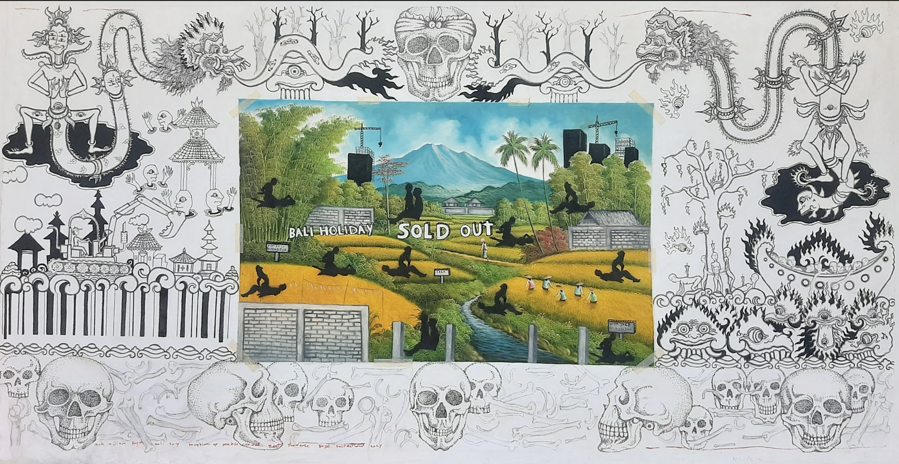

**The Kulturstiftung Basel H. Geiger | KBH.G is delighted to announce that, following its presentation in Basel, parts of the ROOTS exhibition will also be displayed in Bali. Behind this project is the author, filmmaker and curator Michael Schindhelm.**

The exhibition revolves around the fascinating figure of Russian-born German artist **Walter Spies** (1895 – 1942), whose influence on Bali's cultural landscape reverberates today. Spies' legacy is deeply intertwined with Bali's contemporary narrative, and *ROOTS* aims to show his profound impact while exploring the island's postcolonial legacy over the last century.

At the heart of *ROOTS* lies Villa Iseh, a retreat built by Spies in 1937 in Iseh, Karangasem. Initially a sanctuary for Spies, it later became a renowned destination for the rich and famous, including David Bowie, Yoko Ono, and Mick Jagger. The exhibition will examine the themes of mass tourism, environmental degradation, and the complex interplay of cultural identities in Bali.

Highlights include works by the painter Made Bayak and the graphic artist Gus Dark, who explore the Balinese struggle to preserve their cultural identity amidst contemporary challenges, along with a number of films and installations that will present pivotal moments in Balinese history, including the 1965 genocide.

Excerpts from Michael Schindhelm’s docu-fiction film *ROOTS* will accompany the exhibition. The film presents Walter Spies as a spectral presence navigating Bali's modern landscape. Through encounters with Balinese artists and luminaries, the ghost of Spies grapples with his own legacy and the enduring impact of Western civilization on the island. Visitors will be invited to accompany him on his journey across today’s island, 99 years after the painter's first visit.

*ROOTS* honours Spies' enigmatic legacy, weaving his story into Bali's contemporary narrative and exploring the complexities of cultural exchange**.** Through the dancer Dewa Ayu Eka Putri, the musician Putu Tangkas Adi Hiranmayena, and Balinese collaborators, including internationally renowned choreographer Wayan Dibia, founder and owner of Arma Museum Agung Rai and many others, the spirit of Spies will be awoken within this exhibition.

In 1923, Walter Spies embarked on a journey from Europe to the tropics in search of a new world and artistic inspiration. Despite his significant influence as an artist, his story has largely faded from the Western consciousness. Born in Moscow in 1895 and tragically perishing at sea off Sumatra in 1942, Spies' legacy remains enduringly influential in Bali a century after his arrival on the island. Regarded by Balinese as a pioneer of modernism on the island, Spies underwent a profound artistic transformation under the pervasive influence of Balinese art. Despite exhibitions in Berlin and Dresden and friendships with esteemed artists from Oskar Kokoschka and Otto Dix to Friedrich Murnau, Margaret Mead and Charlie Chaplin, Spies' reputation in his homeland pales in comparison to his revered status in Bali.

Michael Schindhelm says, “*The exhibition Roots and the docufiction of the same name are to be understood as a collective memory project that deals with an important aspect of Bali's post-colonial history: the influence of Western modern culture on Balinese cultural traditions. The chequered history of Walter Spies on the island and its after-effects on the subsequent transformation of Bali into a global tourism destination are understood as a ‘shared heritage’. Together with protagonists of Balinese culture today, Roots attempts to place the legacy left by Walter Spies in its historical context and at the same time to understand its significance for the development of Bali today.”*

Michael Schindhelm’s docu-fiction ROOTS will be screened at various locations in Bali between 21 May and 14 June. It will be concluded with a special screening and award ceremony for local students on 14 June at the Arma Museum.

**PRESS INFORMATION**

Yudha Bantono

+62 81338121462

yubantono@gmail.com

**NOTES TO THE EDITOR**

**About Michael Schindhelm**

Michael Schindhelm is a German-born Swiss author, filmmaker, curator, and cultural consultant known for his multifaceted contributions to the arts. He served as the director and artistic director of the Theater Basel from 1996 to 2006. He was the founding director of the Dubai Culture & Arts Authority in 2008 and the general director of the Berlin Opera Foundation from 2005 to 2007. His extensive career includes accolades such as the Bavarian Theater Prize for Theater Basel in 1999 and 2001, and more recently, the Herbert Quandt Media Prize and the German Business Film Prize for his 2022 documentary ‘A Vaccine at the speed of Light’ ( Projekt BioNTech). Beyond his professional achievements, Schindhelm has a rich academic background, having studied Quantum Chemistry in the USSR and later contributing to literature with books including "Lavapolis" and "Dubai Speed." His cinematic endeavours include documentaries such as "Song from the Steppe" in 2004, "Bird's Nest" in 2008, "The Chinese Lives of Uli Sigg" in 2016, and "In the Mood for Art" about the M+ Museum in Hong Kong in 2023, showcasing his diverse talents in the arts.

michaelschindhelm.com

**About the ARMA Museum:**

The ARMA Museum was founded by Agung Rai, a Balinese who has devoted his life to the preservation of Balinese art and culture. The Museum was officially opened on June 9, 1996 by Prof. Dr. Ing. Wardiman Djojonegoro, the Minister for Education and Culture of the Republic of Indonesia. The museum is administered by ARMA Foundation set up on 13 May 1996.  
  
Some of the major purposes of ARMA museum are to preserve artworks, to develop and preserve the art of painting, sculpture, dance, music, and various other cultural art forms; to provide means and infrastructure for local society to learn various artistic skills.  
  
The permanent exhibition of paintings by Balinese, Indonesian and foreign artists includes the collections of the ARMA Foundation and works on loan from the collections of Mr. and Mrs. Agung Rai.  
  
The paintings range from traditional to contemporary, including: Classical Kamasan painting on tree bark, Masterpieces by Batuan artist of the 1930’s and 1940’s, The only works to be seen on the island of Bali by 19th century Javanese artist Raden Saleh Syarif Bustaman, and German painter Walter Spies.

**About Walter Spies**

Walter Spies was a German artist who spent the last years of his life in Indonesia. After he left Moscow, where he was born, he sailed to the Dutch East Indies after he had been made curious by various Dutch postcards. Firstly, Spies lived in Bandung and then moved to Yogyakarta, where he worked for the Sultan, before moving to Ubud in Bali in 1927. He recorded and collected many aspects of Balinese arts, which he then preserved in the museum he founded, the Bali Museum. In 1936, he was one of the founders of Pita Maha, an arts organisation. Together with Wayan Limbak, he developed the Sang Hyang dance and the Ramayana epic to become what we now know as the Tari Kecak (Monkey Dance). In 2018 Michael Schindelm published the first German language biography of Walter Spies.

**About Made Bayak:**

Made Bayak was born in Tampaksiring, Gianyar and showed promising artistic and musical talent at an early age. He studied at the Indonesian Institute of Fine Arts (ISI) in Denpasar from 1999 to 2006. He has built a large social network that provides him with many opportunities to participate in high-profile community activities. These activities combine various forms of creative expression and aim to raise awareness of the social and environmental issues facing the Balinese and international community in Bali today.

**About Gus Dark:**

Gus Dark was born on 21 July 1982 in East Bali. He loves drawing, music and films, and from a young age was known for his great love of art. If someone in the neighbourhood needed a drawing, they were sent to him. He studied graphic design at the Modern Design School in Jogja, where he met other artists who influenced his work. To this day, he continues to communicate his ideas and criticism on social media and communities through the medium of art.

**About the Kulturstiftung Basel H. Geiger | KBH.G**

The Kulturstiftung Basel H. Geiger is a leading cultural foundation dedicated to fostering innovative and thought-provoking artistic experiences. With a commitment to interdisciplinary collaborations, the foundation seeks to engage audiences in meaningful conversations about contemporary issues. Founded in 2019 by philanthropist Sibylle Geiger (1930 - 2020), the foundation is named after her grandfather, Swiss pharmacist and entrepreneur Hermann Geiger (1870 - 1962). The establishment of the foundation is linked to the goal of providing the city of Basel and its residents and visitors with a novel forum for art and culture. Admission and the accompanying catalogue are free.

[kbhg.ch](https://www.kbhg.ch/de/1033/Media-Relations) | [Instagram](https://www.instagram.com/kbhgeiger/?hl=de) | [Facebook](https://www.facebook.com/kbhgeiger/) | [Twitter](https://twitter.com/kbhgeiger)